**Excercise 6 Date:**

**Experiment with different layouts and color schemes for an app. Collect user feedback on aesthetics and usability using GIMP(GNU Image Manipulation Program (GIMP)**

#### **AIM:**

#### The aim is to trial different app layouts and color schemes and evaluate user feedback on aesthetics and usability using GIMP.

**PROCEDURE:**

**Tool Link: https://www.gimp.org/**

#### **Step 1: Install GIMP**

* **Download and Install:** Download GIMP from GIMP Downloads and install it on your computer.

#### **Step 2: Create a New Project**

1. **Open GIMP:**
   * Launch the GIMP application.
2. **Create a New Canvas:**
   * Go to File -> New to create a new project.
   * Set the dimensions for your app layout (e.g., 1080x1920 pixels for a standard mobile screen).

#### **Step 3: Design the Base Layout**

1. **Create the Base Layout:**
   * Use the Rectangle Select Tool to create sections for different parts of your app (e.g., header, content area, footer).
   * Fill these sections with basic colors using the Bucket Fill Tool.

**Example Output: A base layout with defined sections for header, content, and footer.**

1. **Add UI Elements:**
   * **Text Elements:** Use the Text Tool to add text elements like headers, buttons, and labels.
   * **Interactive Elements:** Use the Brush Tool or Shape Tools to draw buttons, input fields, and other interactive elements.

**Example Output: A layout with labeled sections and basic UI elements.**

1. **Organize Layers:**
   * Use layers to separate different UI elements. This allows you to easily modify or experiment with individual components.
   * Name each layer according to its content (e.g., Header, Button1, InputField).

#### **Step 4: Experiment with Color Schemes**

1. **Create Color Variants:**
   * **Duplicate Layout:** Duplicate the base layout by right-clicking on the image tab and selecting Duplicate.
   * **Change Colors:** Use the Bucket Fill Tool or Colorize Tool to change the colors of the UI elements in each duplicate.

**Example Output: Multiple color variants of the same layout.**

1. **Save Each Variant:**
   * Save each color variant as a separate file (e.g., Layout1.png, Layout2.png, etc.).
   * Go to File -> Export As and choose the file format (e.g., PNG).

#### **Step 5: Collect User Feedback**

1. **Prepare a Feedback Form:**
   * **Create Form:** Create a feedback form using tools like Google Forms or Microsoft Forms.
   * **Include Questions:** Include questions about the aesthetics and usability of each layout and color scheme.
2. **Share the Variants:**
   * **Distribute Files:** Share the image files of the different layouts and color schemes with your users.
   * **Provide Instructions:** Provide clear instructions on how to view each variant and how to fill out the feedback form.
3. **Gather Feedback:**
   * Collect responses from users regarding their preferences and suggestions.
   * Analyze the feedback to determine which layout and color scheme are most preferred.

#### **Step 6: Iterate and Refine**

1. **Refine the Design:**
   * Based on the feedback, make necessary adjustments to the layout and color scheme.
   * Experiment with additional variations if needed.
2. **Final Testing:**
   * Conduct a final round of testing with the refined design to ensure usability and aesthetic satisfaction.

**OUTPUT:**

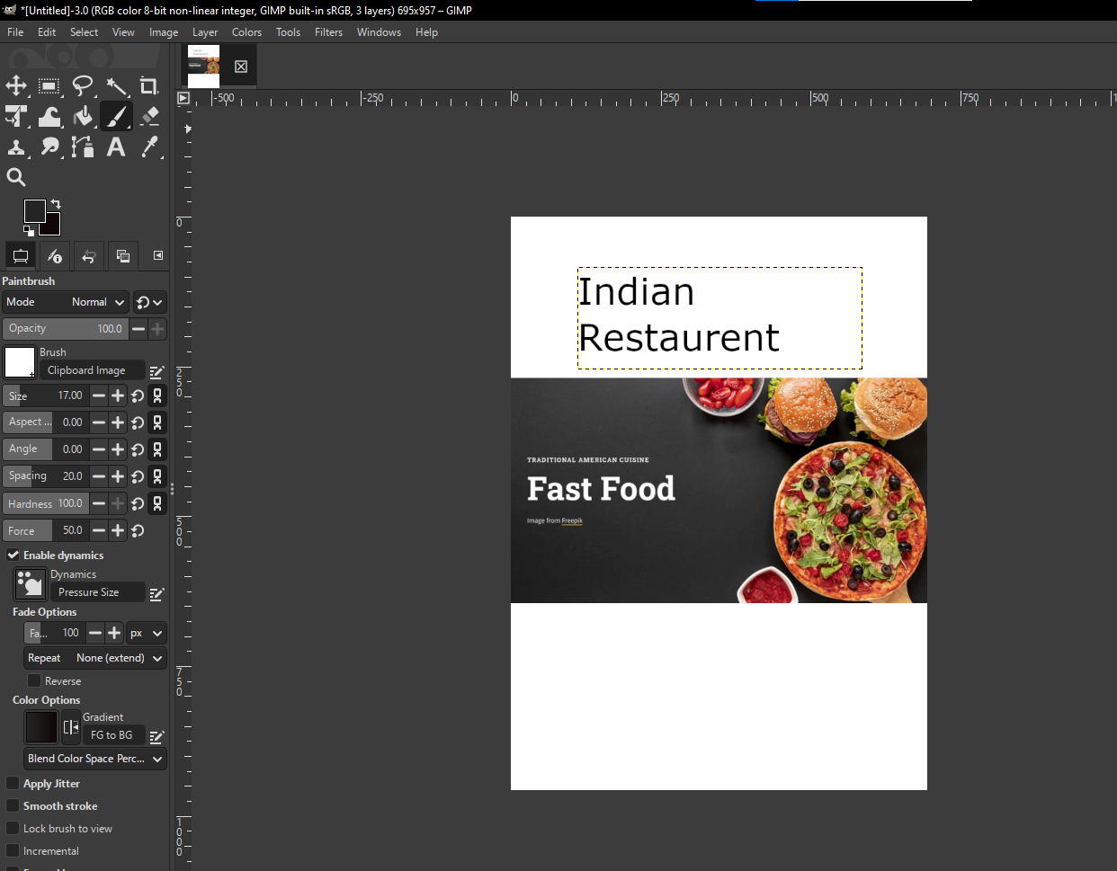

**RESULT:**

